**LANGUAGE LEARNING APPLICATION**

**Abstract:**

Language learning apps have transformed how we learn new languages, making it more engaging and flexible. They use videos, interactive games, and speech recognition to keep users interested and help with pronunciation. AI personalizes the learning experience, adapting to each user's pace and style. These apps also teach cultural context to provide real-world understanding. Users can learn anytime, fitting lessons into their schedules. To keep users motivated, apps offer daily challenges, reminders, and community features for social learning. Advances in technology, like AI and virtual reality, make these apps even more effective and immersive. Despite their benefits, they must ensure content accuracy and cater to different learning levels. Overall, these apps provide a fun and convenient way to learn languages.

Under the guidance of Presented By:

Mr. Krishnanand S H P. Manisha(66G9)

R. Naveena(66H3)

E. Shravani(6615)

**INTRODUCTION:**

The language learning application is a user-friendly tool designed to help people master new languages conveniently. Users can select from a variety of languages and progress through structured lessons and quizzes tailored to their skill level. The app tracks users progress, offering feedback and certifications upon completion of milestones. Subscription options provide access to premium features and resources, enhancing the learning experience. With its interface and comprehensive approach, the language learning application transforms the task of language into an engaging and rewarding journey for learners worldwide.

**FUNCTIONAL REQUIREMENTS:**

**User Authentication:**

The system must allow users to create accounts and log in securely.

Users should be able to reset their passwords if forgotten.

**Lesson Content Management:**

The app should organize lessons by language level (beginner, intermediate, advanced).

Users can access vocabulary lists, grammar explanations, and practice exercises.

**Interactive Exercises:**

The system must provide interactive quizzes, flashcards, and language games.

Users can practice reading, writing, listening, and speaking skills.

**Progress Tracking:**

Users should see their progress (e.g., completed lessons, quiz scores).

The app can motivate learners by showing achievements or badges.

**Social Features:**

Users can connect with other learners or native speakers.

Language exchange or chat features allow real-world practice.

**Notifications and Reminders:**

The app sends reminders for daily practice or upcoming lessons.

Users receive notifications about new content or community updates.

Remember, these functional requirements guide the development process, ensuring that the language learning app meets user needs effectively.

**ER DIAGRAM:**

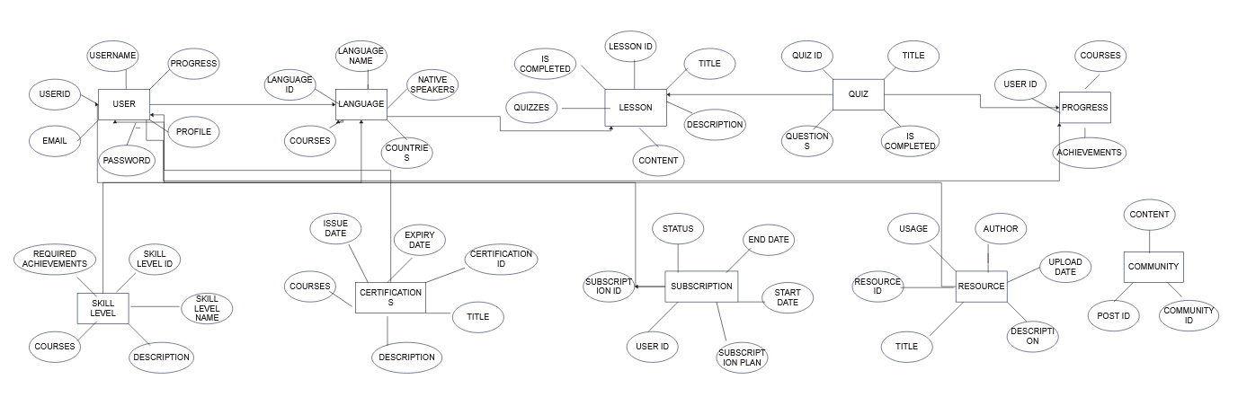

**QUERIES TO CREATE DATABASE:**

CREATE TABLE Users (

userID INT PRIMARY KEY AUTO_INCREMENT,

username VARCHAR(50) NOT NULL,

email VARCHAR(100) NOT NULL,

password VARCHAR(100) NOT NULL,

profile TEXT,

progress INT DEFAULT 0

);

CREATE TABLE Language (

languageID INT PRIMARY KEY AUTO_INCREMENT,

name VARCHAR(50) NOT NULL,

nativeSpeakers INT,

countries TEXT

);

CREATE TABLE Lesson (

lessonID INT PRIMARY KEY AUTO_INCREMENT,

title VARCHAR(100) NOT NULL,

description TEXT,

content TEXT,

exercises TEXT,

quizzes TEXT,

isCompleted BOOLEAN DEFAULT FALSE

);

CREATE TABLE Quiz (

quizID INT PRIMARY KEY AUTO_INCREMENT,

title VARCHAR(100) NOT NULL,

questions TEXT,

isCompleted BOOLEAN DEFAULT FALSE

);

CREATE TABLE Progress (

userID INT,

courses TEXT,

achievements TEXT,

FOREIGN KEY (userID) REFERENCES Users(userID)

);

CREATE TABLE SkillLevel (

skillLevelID INT PRIMARY KEY AUTO_INCREMENT,

name VARCHAR(50) NOT NULL,

description TEXT,

courses TEXT,

requiredAchievements TEXT

);

CREATE TABLE Certification (

certificationID INT PRIMARY KEY AUTO_INCREMENT,

title VARCHAR(100) NOT NULL,

description TEXT,

requirements TEXT,

courses TEXT,

issueDate DATE,

expiryDate DATE

);

CREATE TABLE Subscription (

subscriptionID INT PRIMARY KEY AUTO_INCREMENT,

userID INT,

plan VARCHAR(50),

startDate DATE,

endDate DATE,

status VARCHAR(20),

FOREIGN KEY (userID) REFERENCES Users(userID)

);

CREATE TABLE Resource (

resourceID INT PRIMARY KEY AUTO_INCREMENT,

title VARCHAR(100) NOT NULL,

description TEXT,

category VARCHAR(50),

uploadDate DATE,

author VARCHAR(100),

usage TEXT

);

CREATE TABLE Community (

communityID INT PRIMARY KEY AUTO_INCREMENT,

postID INT,

userID INT,

content TEXT,

timestamp DATETIME,

FOREIGN KEY (userID) REFERENCES Users(userID)

);

**CLASSES AND METHODS UML DIAGRAM:**

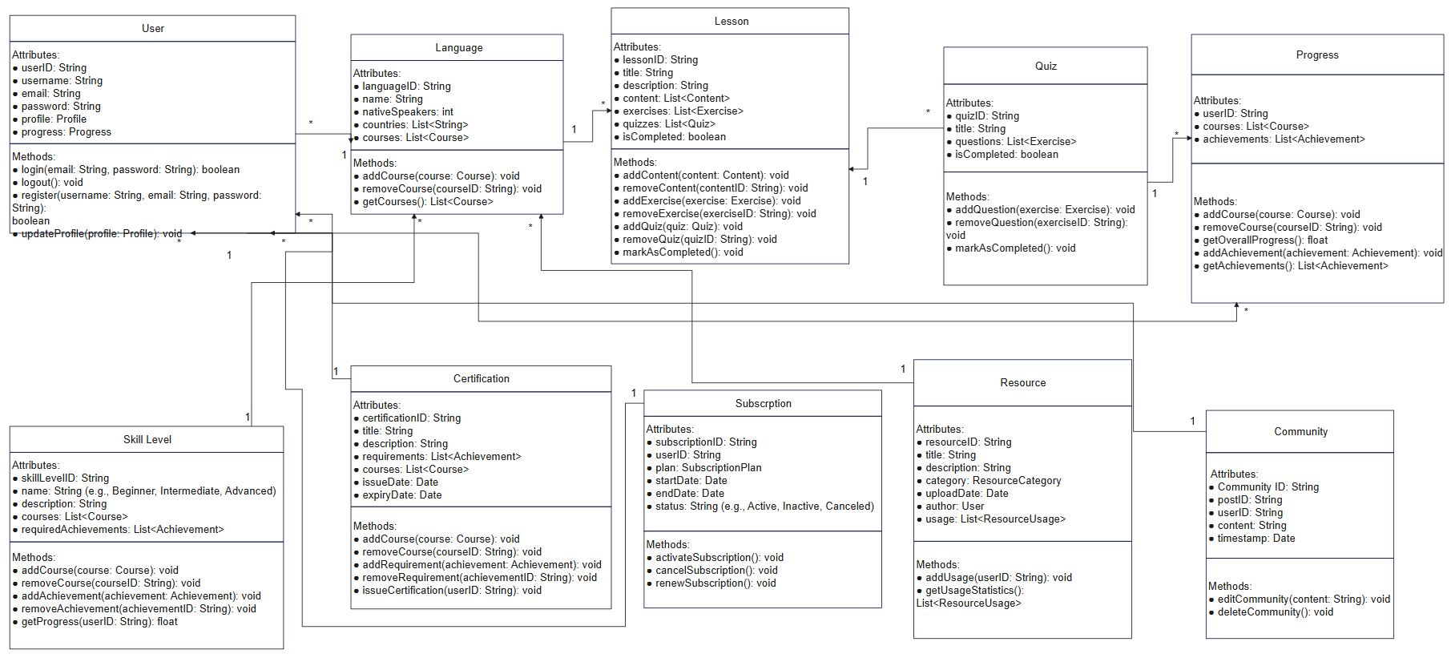

**CHALLANGES LIST:**

* Understanding complex database structures and relationships.
* Translating abstract concepts into concrete code implementations.
* Meeting project deadlines while balancing other academic commitments.
* Collaborating effectively within a team, ensuring consistent communication and task delegation.
* Maintaining code quality through proper documentation, testing, and refactoring.
* Overcoming technical limitations or resource constraints with creative solutions.